Day-4 OUTPUTS

PROGRAM-1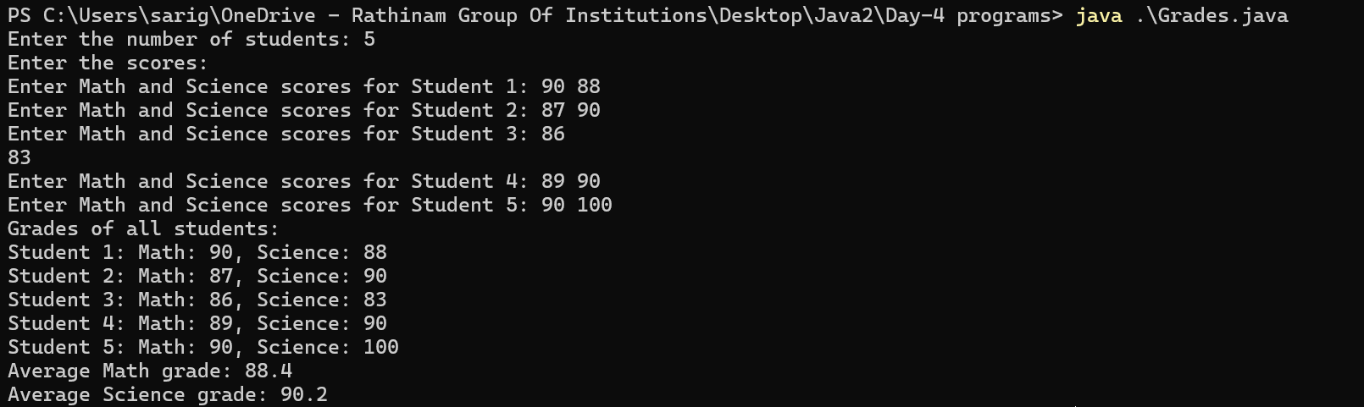

PROGRAM-2

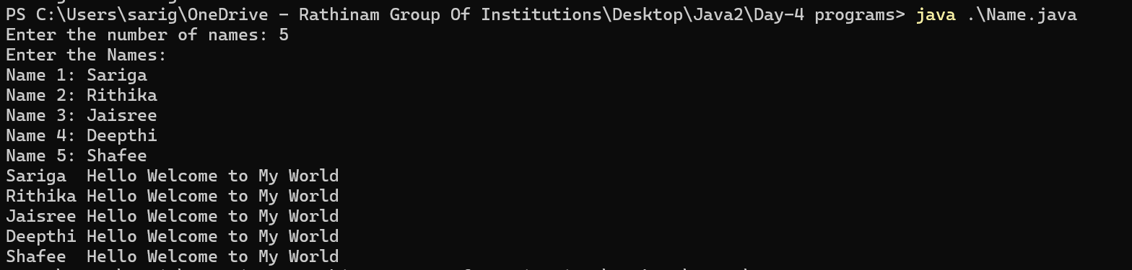

PROGRAM-3

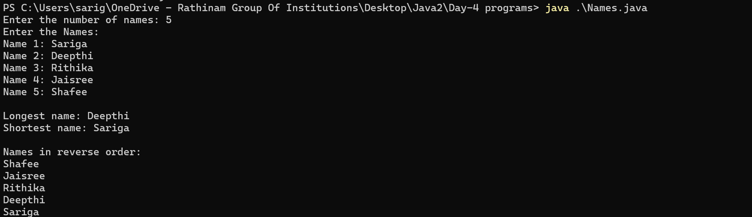

PROGRAM-4

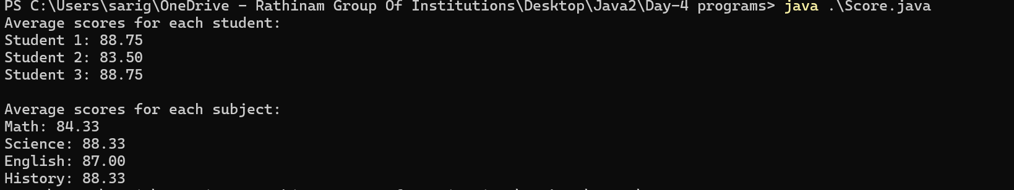

PROGRAM-5